Prepare weather data for MATLAB

Open EXCEL

Chose Open file FRA_Lyon.074810_IWEC.epw.txt

Delimiter -> Next

Comma -> Next

General

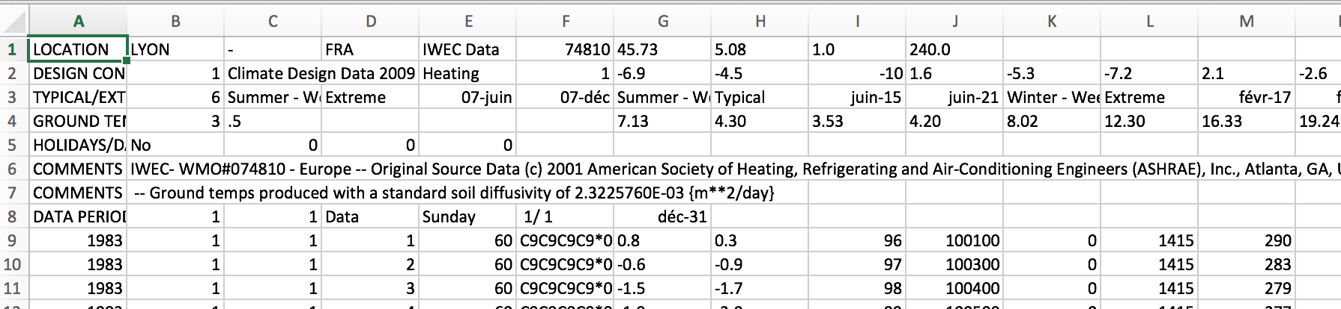

Delete lines 1-9

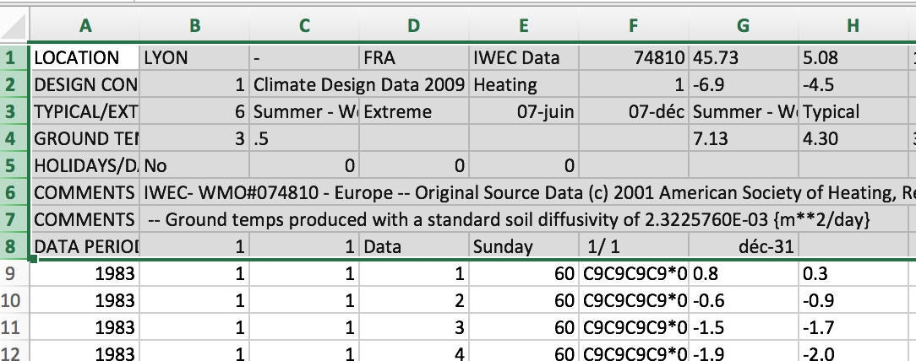``

Delete column F

Save file as .xls

Save file as comma-separated values file .csv FRA_Lyon.csv

Load in a text editor and save again.